**Amazon Web Service – POC**

Using AWS, we have leveraged the power of Cloud to get hands-on in AWS EC2 (Elastic Compute Cloud) and AWS RDS (Relational Data Store) to perform our development activities including Creating instances, Databases, Security & Firewall settings and IAM (Identity & Access Management).

**Use Case – Employee Management App**

* Employee Management App should have functionalities for
  + Creating a new employee
  + Updating employee details
  + Deleting employee details
  + Retrieving the employee details
* App should be deployed in AWS – EC2 instance & should use AWS – RDS Oracle DB for performing DB Operations
* App should have Swagger UI Implementation to have REST Documentation & also to test the REST Endpoints
* Build a Docker image of this App & deploy the Docker image in Docker container

**Tech Stack Details**

* SpringBoot with REST
* Hibernate
* Docker
* Swagger UI

**AWS Screenshots**

**Creating EC2 – Linux instance**

**Steps:**

* Login to AWS Console [<https://aws.amazon.com/>] and search for EC2 in the search box

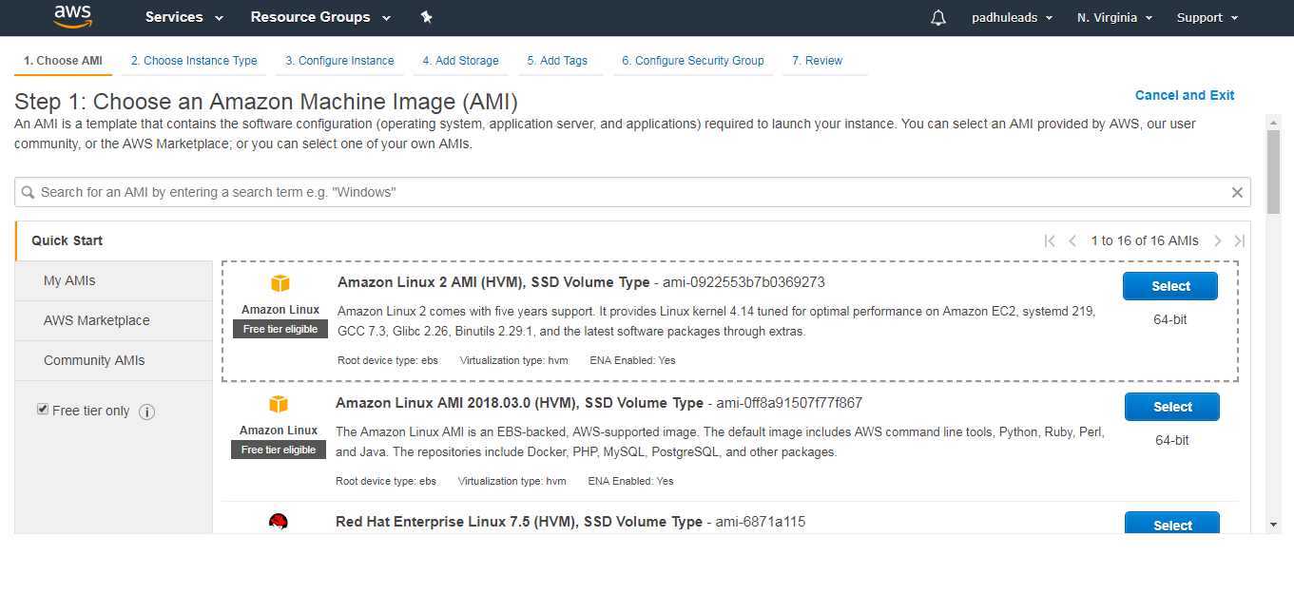

* In the above page,
  + Step 1: **Choose AMI** (Amazon Machine Image) which will give a list such as Linux, Red Hat, Ubuntu etc., Select the required one.
  + Step 2: **Choose Instance Type** such as t2. micro,

t2. small, t2.large depending upon CPU & RAM requirements

* + Total there will be 7 steps, as of now everything can be set to default for R&D purpose. So, Click on Next in the subsequent steps & Launch the instance
  + After that, there will be a prompt to create a key pair for accessing this instance.
  + Select 🡪 create a new key pair & provide a key name [Save this key name] & click on download “**Download Key pair”**

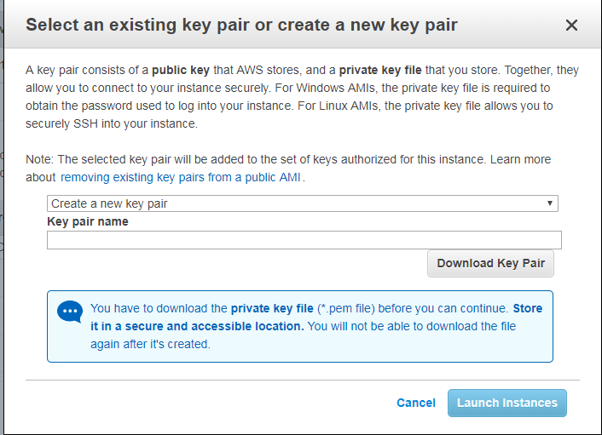

* This will download a private key file (.pem file). Save this file as it will be required to generate a PPK [Private Putty Key] from PuttyGen to access the EC2 instance. After this click on – **Launch Instances**

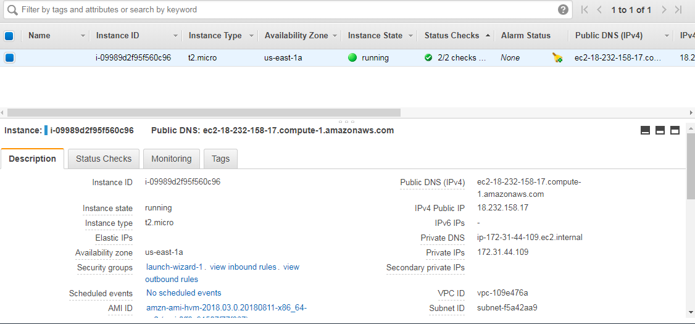

**Creating RDS – Oracle Instance**

* Search for **RDS** in the search box or it can be found under **Database** & select Oracle DB

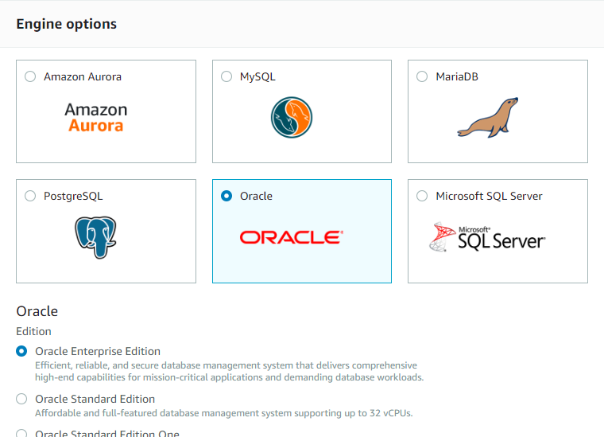

* Provide DB instance name, Master username & password

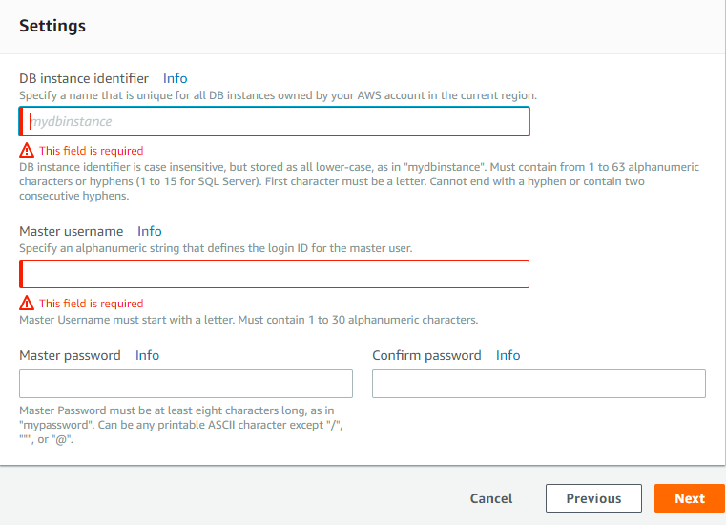

* Provide DB Name & Port and Click Create Database

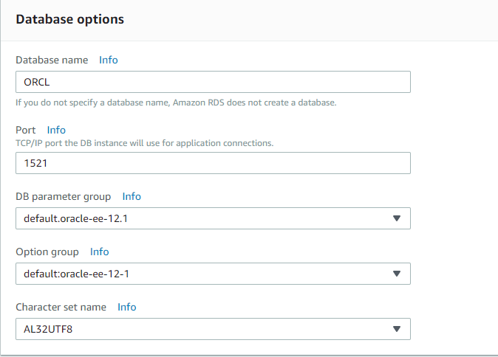

* After few minutes, AWS Oracle DB instance will be created & will be able to view the Endpoints of the DB in the Dashboard

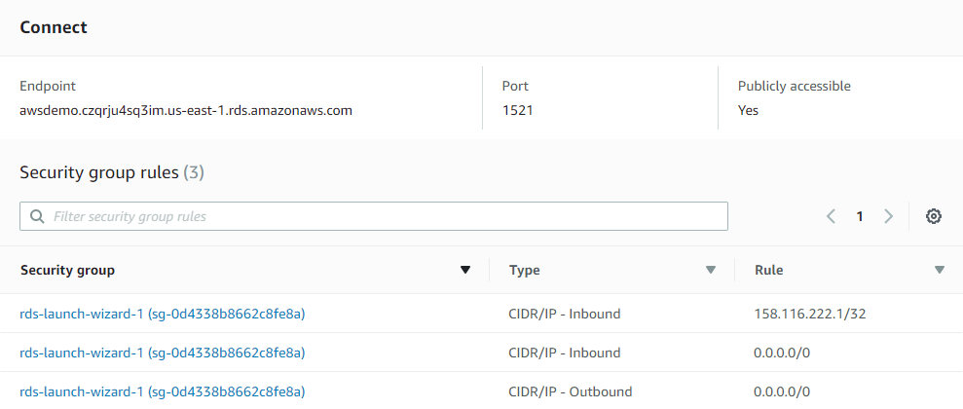

**GitLab Link**

Source Code for Employee Management is available on <http://gitlab.flextronics.com/gssmunej/AWSDemo/tree/master>

To get access to the above link, drop a mail to

* Padmanabhan Velu - [padmanabhan.velu@flex.com](mailto:padmanabhan.velu@flex.com)
* Muneer Ahmed - [MuneerAhmed.J@flex.com](mailto:MuneerAhmed.J@flex.com)

**AWS Documentation & Demo Video Link**

[Demo Video Links](https://flextronics365.sharepoint.com/sites/customsolutions/sap_development/Docs%20%20EP/Forms/AllItems.aspx?RootFolder=%2Fsites%2Fcustomsolutions%2Fsap_development%2FDocs%20%20EP%2FCloud%20Computing%2FAWS&FolderCTID=0x01200084F5DF73E9BC434189142A9B98A13D19&View=%7B5F298759-BE52-4477-B541-EC25197EEC0A%7D) available on **SharePoint**

The above link contains,

* AWS Documentation
* Demo Video for creating AWS EC2 instance, installing required software’s, building a Docker image of the App & deploying the docker image in Docker Container.
* Demo Video of the App

**To Discuss more on AWS, Contact**

* Padmanabhan Velu - [padmanabhan.velu@flex.com](mailto:padmanabhan.velu@flex.com)
* Muneer Ahmed - [MuneerAhmed.J@flex.com](mailto:MuneerAhmed.J@flex.com)